###### Complex Engineering Problem

EE433: DIGITAL IMAGE PROCESSING

SEMESTER PROJECT BESE 26

A semester level design project was given to students as complex engineering problem covered by CLO3 of the digital image processing. The project will be carried out by students in groups of 03. The statement is given below.

|  |  |  |  |
| --- | --- | --- | --- |
| Combining the concepts of image processing with machine learning to design decision support systems for image processing based applications | C6 | PLO3 | Medium |

**Classification of HEp-2 staining patterns:**

Computer aided diagnosis (CAD) systems can facilitate physicians and help in reducing diagnosis errors. They have tremendous potential to contribute in health care quality, enabling massive screening at moderate cost. To this end, there is a growing interest in the research community to solve challenging medical problems and provide CAD based solutions.

The analysis of Indirect Immunofluorescence (IIF) images is the standard laboratory test for the diagnosis of several autoimmune disorders. Staining is technique used to enhance contrast in the microscopic image and to highlight structures in biological tissues for viewing. The specialist observes cultured cells of the HEp-2 cell line under a fluorescence microscope and makes a diagnosis based on two things 1) on the perceived intensity of the fluorescence signal, that can either be negative, intermediate or positive, and 2) secondly on the type of the staining pattern. The Manual technique, based on human visual inspection, is time-consuming, subjective and dependent on the operator’s experience. This test is also known as antinuclear auto-antibodies (ANA) Test.

The idea is to Automate the process which may be a solution to these limitations, making the process faster and more reliable.

Literature describes six main fluorescent patterns that are shown in Figure for both positive and intermediate levels of intensity. They are homogeneous, nucleolar, speckled (coarse and fine), centromere, and cytoplasmic respectively. Their correct description is fundamental for the differential diagnosis of the pathologies

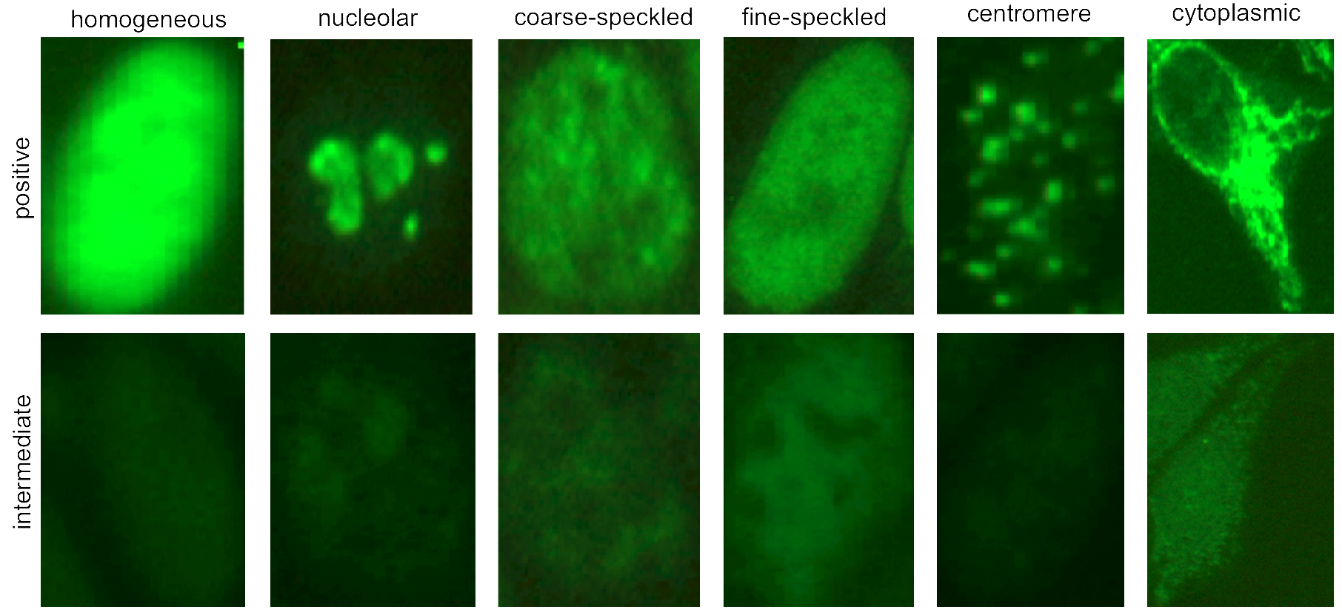

**Data Set:**

* ***MIVIA HEp-2* Image dataset** (28 images, one per patient)
* Labeled Segmented Cells (1455 individual cells)
* Binary masks describing the region of Interest (ROI)

Download Link: <https://mivia.unisa.it/datasets/biomedical-image-datasets/hep2-image-dataset/>

**Segmentation of Hep2 Images**

A fully automatic CAD solution of the ANA test involves in 1) the split-up of individual cell objects from other cells and the slide image background and 2) The classification of cells into staining pattern type. Being the first step in the CAD pipeline, image segmentation is a critical and challenging problem as the performance of subsequent steps heavily depend on the correct separation of HEp2 cells.

The task is to develop an image processing /machine learning algorithm to detect cell images in a whole slide of HEp2 Image. The actual Labels marked by a specialist are given in the dataset. The results of your algorithm shall be evaluated via standard performance metrics discussed below. This involves matching your resultant bounding boxes around cells with labeled masks via the formulas.

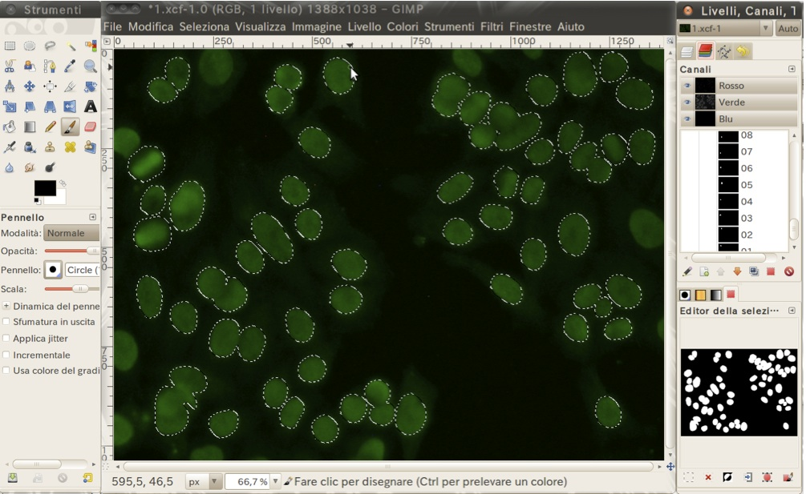

.

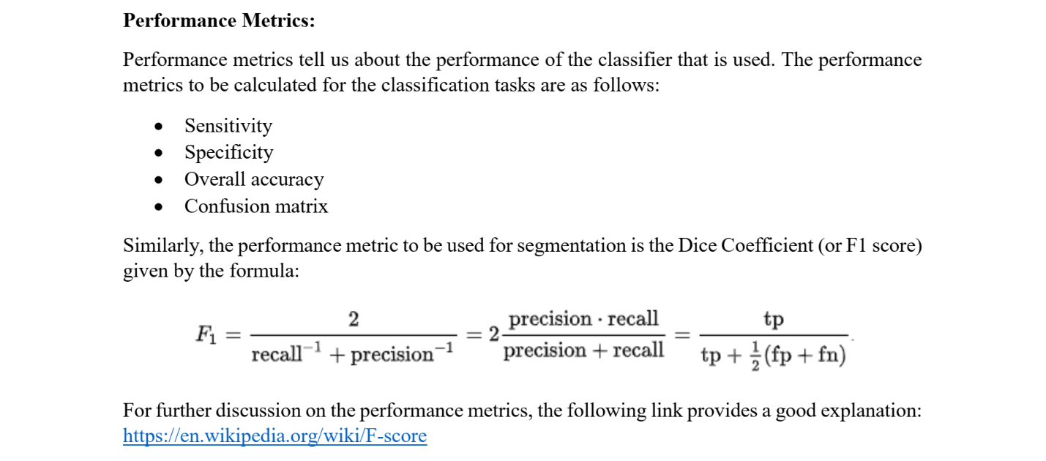**Submission:**

1. A Report of 2 x pages explaining the following:
   * Description of the problem in your own words including related work
   * Algorithmic Pipeline developed for the problem
   * Performance evaluation of your solution
   * Visual results of your solution on the dataset
2. Implementation and demonstration of your solution

**Rubrics used for assessment of semester project (complex engineering problem) are given in Table**.

Table: EE433 Digital Image Processing Project Grading Rubric

|  |  |  |  |  |
| --- | --- | --- | --- | --- |
| **Trait** | **Exceptional**  **(9-10)** | **Acceptable**  **(7-8)** | **Amateur**  **(4-6)** | **Unsatisfactory**  **(0-3)** |
| **Understanding of Problem 25%** | | | | |
| **Problem Understanding**  **Weight = 15%** | The depth of the problem is exceptionally understood. | The depth of problem is understood to a sufficient level. | The depth of the problem is very weak. | There is no knowledge of the problem depth. |
| **Review**  **Weight = 10%** | Related work of the problem is covered to an excellent extent. | Related work of the problem is covered sufficiently except for the latest developments. | Related work covered is very sketchy. | No effort made to cover related work of the selected problem. |
| **Originality of solution with Demonstration Skills 50%** | | | | |
| **Originality**  **Weight = 25%** | The developed solution is original | The solution is original utilizing some already developed components | The solution is partially original utilizing already developed components | The solution is least original |
| **Demonstration**  **Weight = 25%** | Excellent command of project is shown with exceptional question answer session. | Good skills while demonstrating project and fairing fairly good in cross questioning | The demonstration is unorganized and cross questioning session is sketchy. | The demonstration is poor with no organization and fails at the cross questioning session. |
| **Coding and Documentation 25%** | | | | |
| **Specifications**  **Weight = 10%** | The program works and meets all of the specifications. | The program works and produces the correct results and displays them correctly. It also meets most of the other specifications. | The program produces correct results but does not display them correctly. | The program is producing incorrect results. |
| **Readability**  **Weight = 5%** | The code is exceptionally well organized and very easy to follow. | The code is fairly easy to read. | The code is readable only by someone who knows what it is supposed to be doing. | The code is poorly organized and very difficult to read. |
| **Report (Documentation)**  **Weight = 10%** | The documentation is well written and clearly explains what the code is accomplishing and how. | The documentation consists of embedded comment and some simple header documentation that is somewhat useful in understanding the code. | The documentation is simply comments embedded in the code with some simple header comments separating routines. | The documentation is simply comments embedded in the code and does not help the reader understand the code. |

**Score = $\sum{traits_weight*trait_score}$**